PROJECT

PHASE-I

ONLINE MOVIE TICKET BOOKING

**BY:**

Shiva Kumar Pentyala

Ritesh Kumar Reddy Kuchukulla

Sundeep Kumar Allampally

Sandeep Blv

**ABSTRACT**

Online Movie Ticket booking, serves as an all in one system which deals with most of the aspects of current day online ticket booking. With this customers can check and book movie tickets online from anywhere through their devices, enabled with proper internet connection. At times customers may struggle standing for hours and hours to purchase a ticket for the movie they intend to go and may eventually end up with no tickets. This application eschews customer from all of these. OMT also keeps a track of customer records so that it can facilitate customers with extra benefits like showing the film genre that suits customer based on his previous bookings, some special gift vouchers or food coupons.

Main benefits of this application are enhancement of the effectiveness, automation of the actives there by reducing manual entries and making it user friendly.

**Architecture:**

Any user/client can access OMT for checking availability of tickets for a particular show based on show timings, location and type of theater. Users are allowed to make payment in two ways i.e. online (debit card/credit card/online payment website) and offline (details will be e-mailed user has to make payment manually). This website can be accessed by multiple users concurrently. Any user can book any number of tickets at a time. This web app will active irrespective of the time.

System (Database): System job is, it should not come down .It should maintain its consistency. Maintaining a copy of data so as to protect data from system crashes.

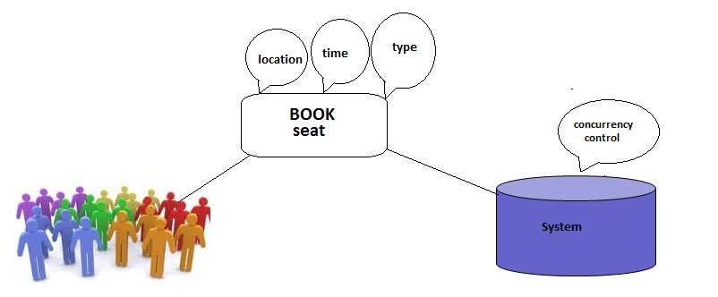

Its major functionalities include:

* Providing information of the theatres, multiplexes, screens etc
* New Releases as well as forth coming movies.
* Providing movies reviews, abstract, etc.
* Displaying show timings.
* Booking tickets.
* Showing alternative chances when tickets for a particular movie at a theatre run out of availability.
* Allowing users to give feedback.

**Scope:**

* We can develop this web app as a mobile app using same features.
* This implementation works for all of the states in US, extension can be made to serve people across the world.
* Accuracy of the data is the main constraint, by using DBMS incorrect information can be avoided.
* Security is the primary concern in these systems; DBMS gives access only to the authorized users.

**Ideas:**

* User can give their views after watching, so based on reviews other users can opt for this show.
* Many users can book their seat, ensuring concurrency control mechanism.
* Special offers will be given while booking seat.
* This web app will be understandable by any user(user-friendly) because we are implementing in many languages.(translators will be provided)

**Platform**:

**Front end:** HTML, CSS, JavaScript, PHP

**Back end:** Mysql

**Team Role**:

All: Requirements, tables and their relationships are discussed among the team members, ERD diagram creation once the team decided on what should be included in the database.

Sujitha and Sowmya: Front end

Jeevana and Sindu: Middle layer

All: Back end